BRITISH ANTARCTIC TERRITORY

THIS LICENCE is granted by the Commissioner pursuant to section 2(1)(b) of the Currency Ordinance 2021.

1. Pobjoy Mint Limited of Millennia House, Kingswood Park, Bonsor Drive, Kingswood, Surrey is hereby authorised by this licence to-

- make during a period of eighteen months from the date of the grant
of this licence and

- issue during a period of two years from the date of the release agreed
to between the Government and Mint

coins in the quantities and of the design and specification set out in the schedule.

2. It is a condition of this licence that every such coin issued must fully comply with the design and specification set out in the schedule.

3. Each such coin made in accordance with the conditions of this licence shall be legal tender in the Territory for its face value from the first date on which that coin was minted.

THE SCHEDULE
(Design, specification, authorised quantity and authorised mint of coins)
Design: 2023 Glaciers of British Antarctic Territory

The obverse of every coin shall consist of the couped portrait of His Majesty King Charles III by Pobjoy Mint Ltd surrounded by the inscription “BRITISH ANTARCTIC TERRITORY” and the year of the minting of the coin.

The reverse design features each of the Glaciers represented on the designs is on Alexander Island in British Antarctic Territory and flows into the George VI Ice Shelf and is signified by the God or Goddess of the same name with an image of the respective planet in the background.

Coin 1: The design represents the Mars Glacier and features an image of the God Mars holding a spear with the planet Mars in the background. The six planets after which the glaciers are named are shown in the surround (Mars, Mercury, Neptune, Saturn, Uranus, Venus) with the value shown at the base of the design.

Coin 2: The design represents the Mercury Glacier and features an image of the God Mercury holding a staff with the planet Mercury in the background. The six planets after which the glaciers are named are shown in the surround (Mars, Mercury, Neptune, Saturn, Uranus, Venus) with the value shown at the base of the design.

Coin 3: The design represents Neptune Glacier and features an image of the God Neptune holding his trident with the planet Neptune in the background. The six planets after which the glaciers are named are shown in the surround (Mars, Mercury, Neptune, Saturn, Uranus, Venus) with the value shown at the base of the design.

Coin 4: The design represents Saturn Glacier and features an image of the God Saturn holding a scythe with the planet Saturn in the background. The six planets after which the glaciers are named are shown in the surround (Mars, Mercury, Neptune, Saturn, Uranus, Venus) with the value shown at the base of the design.

Coin 5: The design represents the Uranus Glacier and features an image of the God Uranus with the planet Uranus in the background. The six planets after which the glaciers are named are shown in the surround (Mars, Mercury, Neptune, Saturn, Uranus, Venus) with the value shown at the base of the design.

Coin 6: The design represents the Venus Glacier and features and image of the Goddess Venus with the planet Venus in the background. The six planets after which the glaciers are named are shown in the surround (Mars, Mercury, Neptune, Saturn, Uranus, Venus) with the value shown at the base of the design.

Specification, authorised quantity and authorised mint of coins (for each of the six designs):
Type | NBCN | Fine Silver (with Gold Plate) | 2oz Silver | 1oz Silver | 1/2gm Gold
Denomination | £2 | £2 | £4 | £2 | £4
Weight | 12.00gms | 12.00gms | 62.12gms | 31.103gms | 0.5gms
Diameter | 28.40mm | 28.40mm | 50.00mm | 38.60mm | 11.00mm
Fineness | Nickle Brass/ Cupro Nickle | Fine 999. Silver + Fine 999.9 Gold Plated Surround | Fine 999. silver | Fine 999. Silver | Fine 999.9 Gold
Quality | Proof-like | Proof | Proof | Proof | Proof
Shape | Round | Round | Round | Round | Round
Edged | Milled | Milled | Milled | Milled | Milled
Quantity | 1,950 | 175 | 200 | 950 | 199

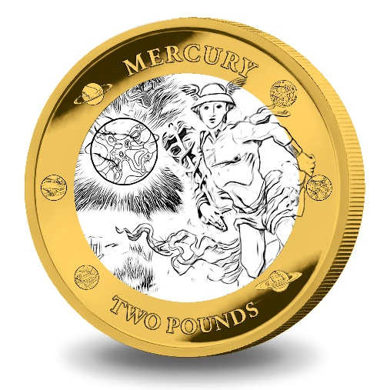
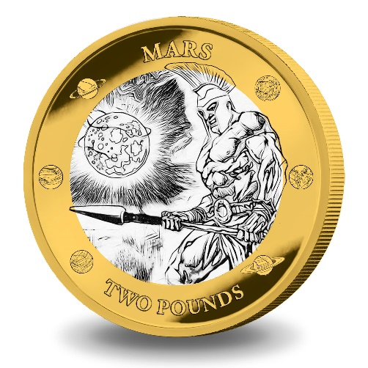

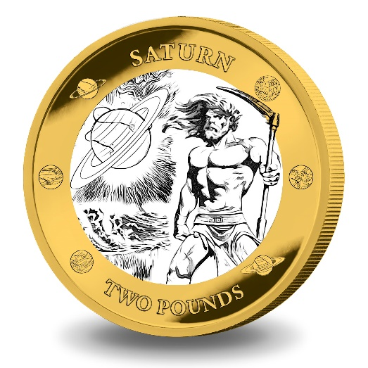
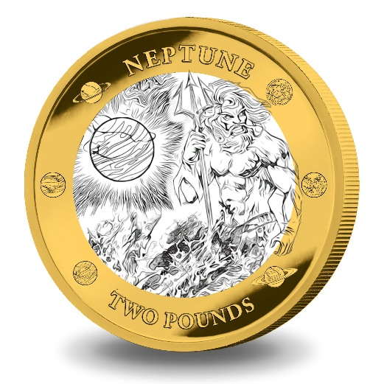

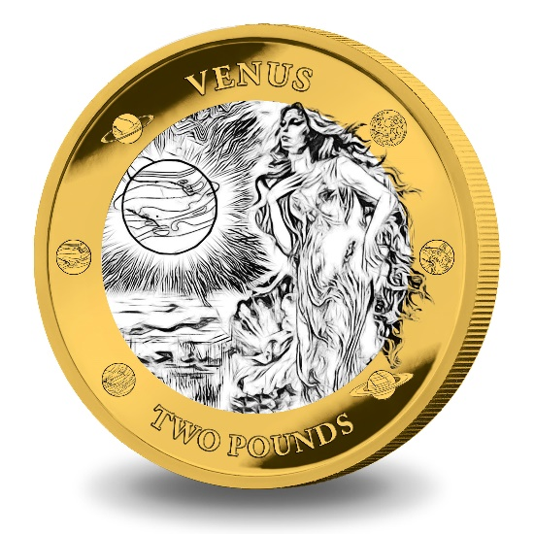
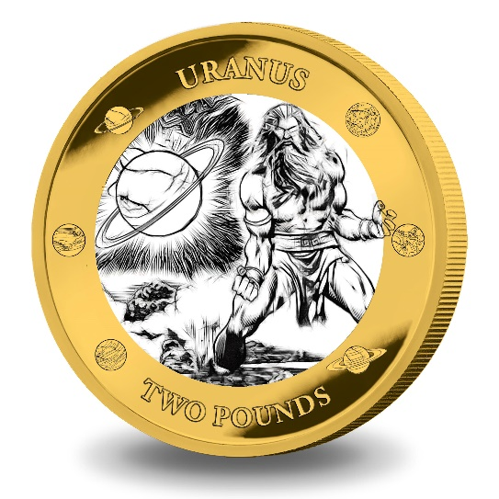

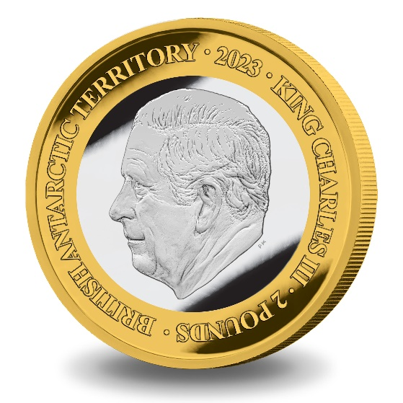

ANNEX TO THE SCHEDULE

IN WITNESS whereof the Commissioner has hereto set his hand this 27th day of February 2023.

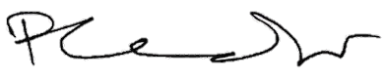[SEALED] Signed by:
[Paul Candler, Commissioner]

